CS 500 Module Seven Activity
Process Summary

Approach and Strategy
For this activity, I planned a simple calculator that allows the user to choose between addition, subtraction, multiplication, and division. I started by creating a flowchart so I could organize the steps of the program before writing the Python script. The flowchart begins with displaying the calculator menu, getting the user's operation choice, asking for two numbers, performing the selected calculation, and displaying the result. I also included a decision for division by zero and a loop that allows the user to complete another calculation or exit the program.
My goal was to keep the program simple and easy to follow while still meeting each requirement in the rubric. Breaking the program into smaller steps made it easier to see how the user's choices would move through the calculator. After the flowchart and pseudocode were completed, the next step was to use the same logic to create and test the calculator in Codio.
Pseudocode
START
DISPLAY calculator menu
DISPLAY 1. Addition
DISPLAY 2. Subtraction
DISPLAY 3. Multiplication
DISPLAY 4. Division
GET user's operation choice
GET first number
GET second number

IF user chooses addition
ADD first number and second number
DISPLAY result
ELSE IF user chooses subtraction
SUBTRACT second number from first number
DISPLAY result
ELSE IF user chooses multiplication
MULTIPLY first number by second number
DISPLAY result
ELSE IF user chooses division
IF second number equals 0
DISPLAY division by zero error
ELSE
DIVIDE first number by second number
DISPLAY result
END IF
END IF

ASK user if they want to perform another calculation
IF user chooses yes
RETURN to calculator menu
ELSE
END program
END IF
END
Issues Encountered and Resolutions
One issue I ran into while creating the calculator was indentation in Python. When I first tried to run the program, I received an IndentationError because some of the if and elif statements did not line up correctly. I also had a problem in the division section where the print statement under the division-by-zero check was not indented enough. I fixed these issues by reviewing the structure of the program and making sure each statement was lined up under the correct if, elif, or else statement. I eventually replaced the affected section with consistently spaced code, which allowed the program to run correctly. This showed me how important indentation is in Python because it determines which statements belong together.
Possible Code Optimization
The calculator is small, so there are not many performance problems to improve. One way I could optimize the program in the future would be to separate each arithmetic operation into its own function. This could make the code easier to read and update if more operations were added later. I could also add input validation so the program does not stop if a user enters letters instead of a number. For this activity, I kept the code simple because the main goal was to practice basic program logic, user input, decisions, loops, and testing.
Unit Testing and Console Output
I tested each arithmetic operation to make sure the calculator returned the expected answer. I tested addition using 5 and 3, which returned 8.0, and subtraction using 10 and 4, which returned 6.0. I also tested multiplication using 6 and 7, which returned 42.0, and division using 20 and 4, which returned 5.0. For an edge case, I entered 10 divided by 0. Instead of crashing, the program displayed an error message stating that it cannot divide by zero. I also tested the loop by entering yes after calculations and confirmed that the calculator menu appeared again. Entering no ended the program and displayed Goodbye.
Figure 1. Addition and subtraction console tests
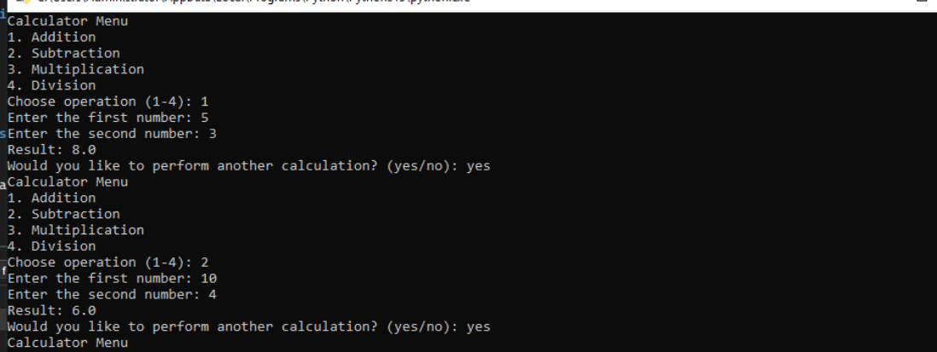
Figure 2. Multiplication, division, division-by-zero, and exit tests
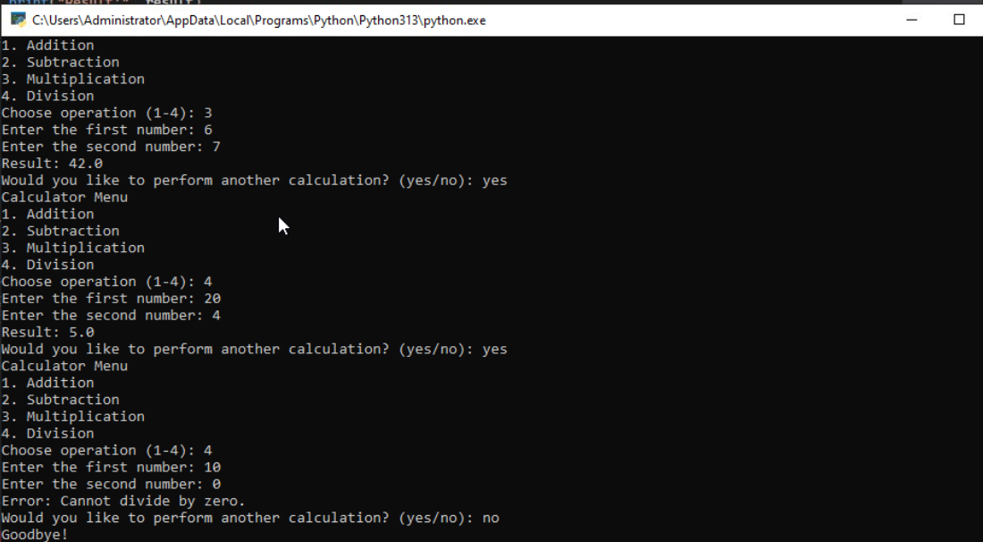
Conclusion
Overall, this activity helped me connect planning, coding, and testing into one process. Creating the flowchart and pseudocode first made the Python program easier to organize. Testing each operation helped confirm that the calculator worked as expected, and testing division by zero showed why edge cases are important. The indentation errors I encountered also gave me practice debugging a problem and correcting the program before completing the final tests.
AI Use Acknowledgment
I used ChatGPT as a support tool to help organize the assignment, review the calculator logic, and troubleshoot Python indentation errors. I completed the work in Visio and Codio/Visual Studio and tested the program myself.

